Ensure that you are Familiar with all these Signs


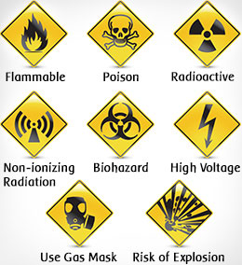

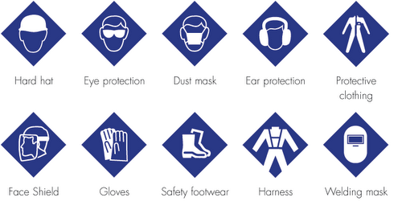

Done by:
Welding Tech & Maintenance Services Ltd Design Department
Welding Tech and Maintenance Services Ltd

Safety
Handbook

2015

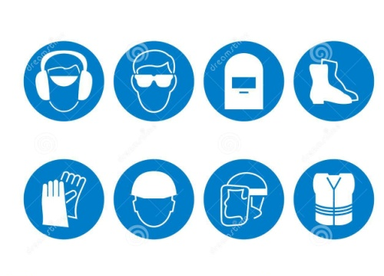
Safety – The condition of being protected from or unlikely to cause danger, risk, or injury.

Research shows that over 99 percent of all accidents are preventable. If you think that accidents just happen, then what allows you to drive down the road, walk down the sidewalk or even live in your home without great fear? The reality is that you have a great deal of control over the circumstances around you, and there are some simple procedures that can ensure workplace safety is maintained. Some of which are:
- Observe and practice the safety procedures established for the job.

- Do not wear loose clothing or jewellery around machinery. It may catch on moving equipment and cause a serious injury.

- Never distract the attention of another person, as you might cause him or her to be injured. If necessary to get the attention of another person, wait until it can be done safely.

- Where required, you must wear protective equipment, such as goggles, safety glasses, masks, gloves, hair nets, etc. appropriate to the task.

- Safety equipment such as restraints, pull backs, and two-hand devices are designed for your protection. Be sure such equipment is adjusted for you.

- Never use machines that do not have guards in place

- Pile materials, skids, bins, boxes, or other equipment so as not to block aisles, exits, fire fighting equipment, electric lighting or power panel, valves, etc. Fire Doors and Aisles must be kept clear!
- Keep your work area clean. A clean work area free of hazards promotes safety and drastically reduces the risk of injury.
- Shut down your machine before cleaning, repairing, or leaving it.
- Do not exceed a speed that is safe for existing conditions.
- Running and horseplay are strictly forbidden.
- Do not block access to fire extinguishers.
- Etc.

